
Garden of Happiness

www.gardenofhappiness.org

Friendship dances around the world bidding us all to
awaken to the recognition of happiness. (Epicure)

The pursuit of happiness

While the Negroes toiled in the bloody sun
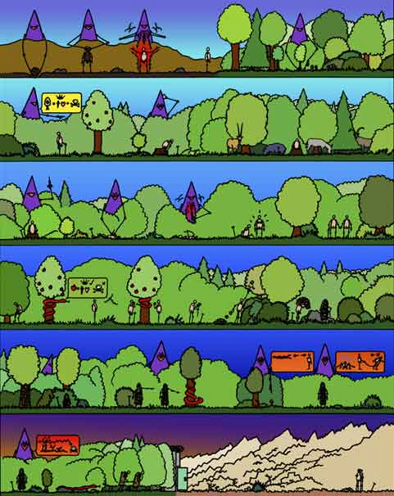the bleeding feet bound together by chains
even those of the girl who was the master's whore,
in the cool house the master's wife was having fun
playing with her children, not knowing
she'll loose the eldest in the succession war
and in the cottonfields at high noon
a singing voice raised mighty loud
oh be joyful, freedom will come soon.

Life goes on
no matter when or why
the duty of us all to try
to silence the human cry
Chad McCail and justice to be won.

While people were gassed at Auschwitz
and if not yet ate one cup of watery soup
doubting themselves to be man or beast,
in the neighbouring village, relatively rich
a blushing blue eyed blond boy was born
the family giving only a wartime feast
and in the camp a man made a great deal
one inch of rope for a quarter of a cigarette
surely soon to be exchanged for half a meal.

Life goes on
no matter when or why
the duty of us all to try
to silence the human cry
and justice to be won.

While children in the Nike factory sweat
twelve hours a day, six days a week
yet being fired for going to the loo
at a party I can't choose, green or red
which cocktail fit best to my shirt, yet
no bloody drink to stop me from feeling blue
and near the sweatshop a child's stinking hand
scratch the refuse dump for a million plastic bottles
and soon that one way ticket to our land.

Life goes on
no matter when or why
the duty of us all to try
to silence the human cry
and justice to be won.

